The Enquiry About The Payment That Do Not Go Through :ContractNumber 6483244 : Estate Late G Tjiuongua. - Ref. [CBA9725554]
First approach:
check for AUADMOUT file
look for policy -> for A B and C no active benefit found.
it means either there is no active benefit segment or dates are incorrect.
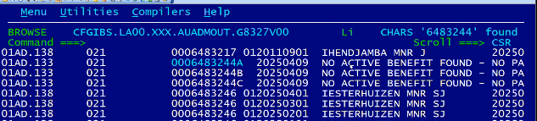
Response:
The policies that Siviwe was querying were all paid last night.there was a data error that was fixed last night and the payments went through.
Solution approach:
If policy cant found check for all scenario and splits, 01, 1 or 01,5 or 02,1
for example above policy is 02,1 and check for all split.
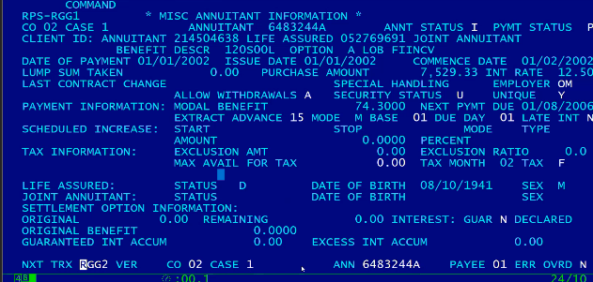
also verified above policy is Split A B and C
now for all 3 split check RGG4 screen next payment date is 01/08/2006
now go on RGD1 ENTER and we can see below dates are wrong
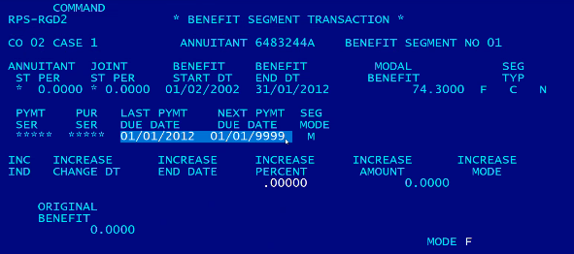

Its back dated within guaranteed period
check on RGG4 main person died on 22/05/2006 policy is now has been reissued to 3 people A B and C
we have to make payment to thise peoples from 01/06/2006 upto 01/12/2012
So the beneficiary split process will reset all the next payment due dates
Check on RGD1
from benefit segment 01 last payment SHOULD BE 01/07/2006 and next pymnets hould be 01/08/2006
on benefit segment 02 those dates should be same as last and next payment should be same as benefit start. If next payment date is before the end of ben seg 01 end date, then next payment and last payment on ben seg 02 must = start date of ben seg 02.
Now solution :
from tsoa download those 3 policies
output of policy unload file open in edit mode and delete all other transaction than GD (GD is benefit transaction) find GD for all policies and delete all other rows.
we will now change the Dates, open file in file-Ad
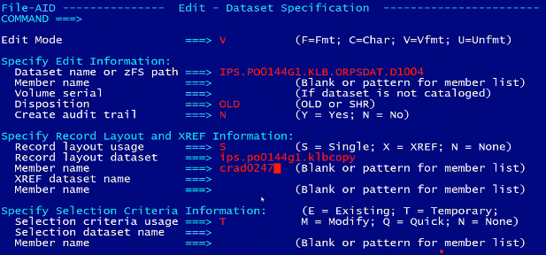
check for split A policy there are 2 records for 2 segment
check for next payment due date and last payment due date and update correct date as below
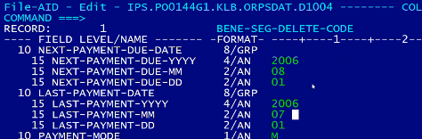
SEGMENT 02 -> If next payment date is before the end of ben seg 01 end date, then next payment and last payment on ben seg 02 must = start date of ben seg 02.
now update for segment 2 (date should be same as benefit start date)
now update for B split and split C same way.
we should check this changes in DEV before we deployed.
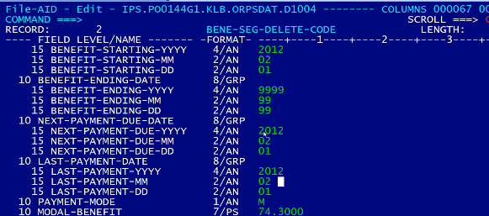

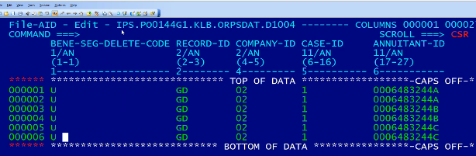
update BENE-SEG-DELETE-CODE to U

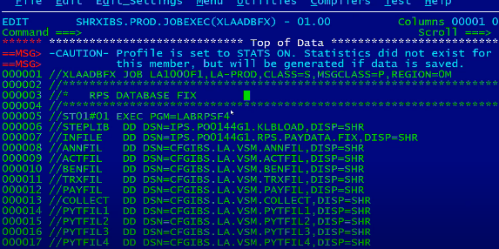
note: job is pointing to Karen’s lib

Update the input file with policy details which we want to make changes
next day verify for all the split you will be able to find payment from 2006 till 2012
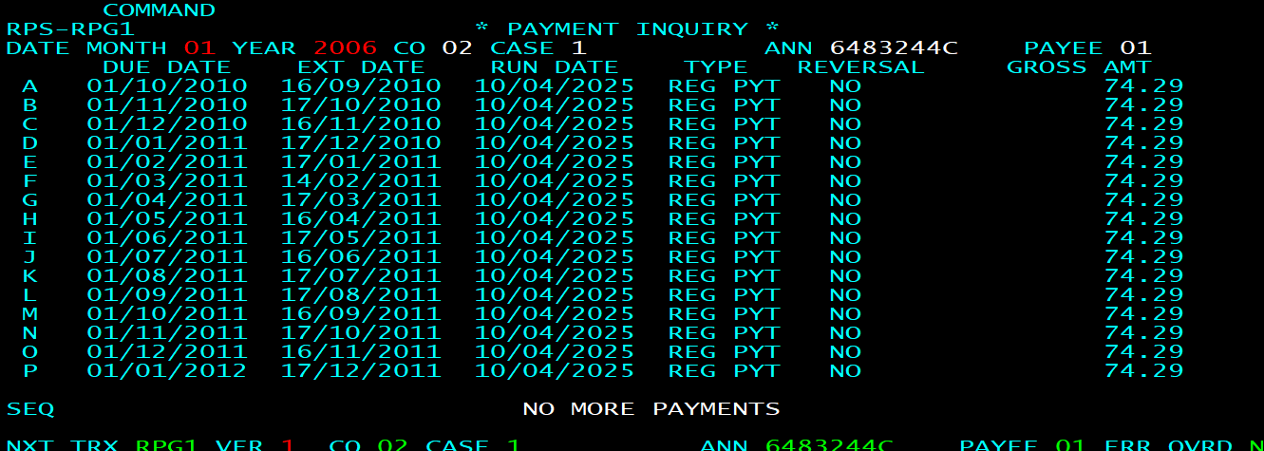

Also we will be able to see ANN and PYMT status will be N policy will go off books.

